 | Autumn 1  Extreme Earth  Science Driver | Autumn 2  Stone Age to Iron Age  History Driver | Spring 1  Humans and Plants  Science Driver | Spring 2  Ancient Egypt  History Driver | Summer 1  The UK  Geography Driver | Summer 2  Reduce, Reuse, Recycle  Geography Driver
Book | Escape From Pompeii (?) | The Iron Man  Ted Hughes  The Lion, The Witch and The Wardrobe  C.S. Lewis | Charlotte’s Web  E.B White | Leila and The City of the Cat Goddess | Shakleton’s Journey  William Gill | Varmints  Helen Ward
English | Recount – Diary Entry  Poetry – Concrete, Volcanoes | Narrative: Character Description  Narrative: setting description | Character Interviews: Hot seating then retelling parts of the story through different character’s eyes  Explanation: Pollination/Lifecycle of a Plant | Non-Chron: Ancient Greek Gods  Instructions: How to make a mummy | Persuasive: Letter of application  Recount: Diary Entry  Explanation: the hat making process | Narrative: Setting Description  Poetry: The Magic Box by Kit Wright
Maths | Place Value, Addition and Subtraction, Measurement, Multiplication and Division. |  | Multiplication and Division, Measurement, Fractions, Decimals. |  | Decimals, Money, Time, Statistics, Properties of Shape, Position and Direction.
RE | How do festivals and worship show what matters to a Muslim? | What is it like for someone to follow God? | What do Hindu’s believe God is like? | Why do Christians call the day Jesus died Good Friday? | What do Christians learn from the Creation Story? | How and why do people try to make the world a better place?
Trip |  | Stone Age Workshop |  | Egyptian Workshop  Manchester Museum | Hat Works
Science | 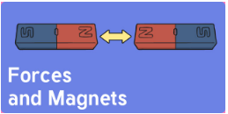 | 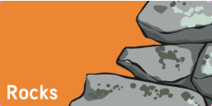 |   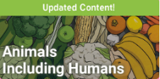 | 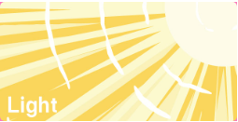 |  | 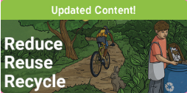
Geography |  |  |  |  |  | 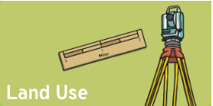
History | Textile | 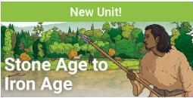 |  | 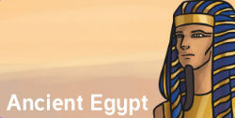 | 
Art | Paint  Shades of colour  Textile – Volcano Relief Art | Drawing  Pattern and mark-making  Printing  Amorite | Printing  Leaf printing to make pictures of animals. | Form  Clay Amulets and Jewellery | Paint – Lowry  Whole year montage of Stockport.  Own scene of Stockport in Lowry | Textile - Mosaic  Gaudi  Sea creatures
D&T |  | Structures  Shelters | Food Technology  Sandwich Making |  |  | Mechanical Systems  Pop-Up technology.
Computing | Online Safety | Coding | Graphing | Spreadsheets | Touch Typing | Presentations
PSHE | SEAL:  New Beginnings  Heart Smart:  High Five  Me as a unique individual | SEAL:  Getting on & Falling out  Heart Smart:  Don’t forget to let love in | SEAL:  Going for Goals  Heart Smart:  Too much selfie isn’t healthy | SEAL:  Good to be Me  Heart Smart:  Don’t rub it in, rub it out  Helping others | SEAL:  Relationships  Heart Smart:  Fake is a mistake | SEAL:  Changes  Heart Smart:  ‘No way through’ isn’t true.  Living in a diverse world.
PE | Hockey  Gymnastics | Basketball  Gymnastics | Tag Rugby  Dance | Cricket  Dance | Rounders  Swimming | Athletics  Swimming
Music | Song Focus – Let your spirit fly | Composition Focus – Glockenspiels | Song focus – Three little birds | Composition focus - Glockenspiels | Song focus – The Dragon Song | Song Focus – Bringing us together
French | Bonjour! Ça va?  Comment ça s’écrit? | Les numéros 0 à 15  Quel âge as-tu ?  Joyeux Noël | De quelle couleur  est-ce ? | En classe  Dans ma trousse | Les animaux domestiques | ‘Ours Brun’

